Functions

1. Confirmation Message  
   A bootstrap alert popups up on the screen to confirm to the user an action they took completed successfully
   1. Message Sent

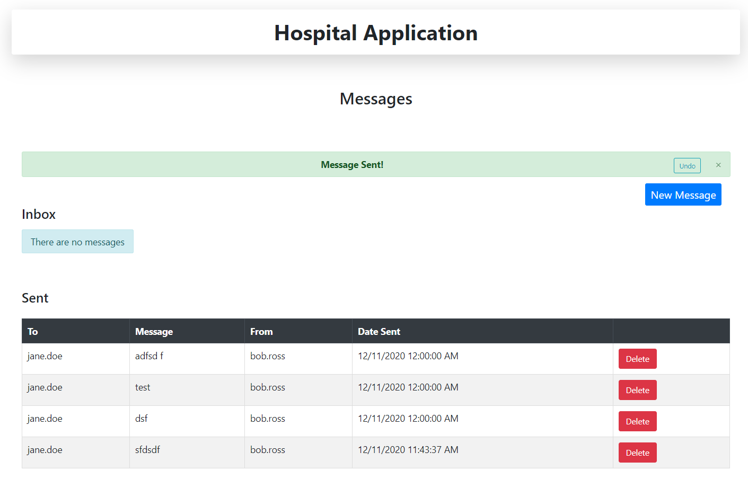

* 1. Message Deleted

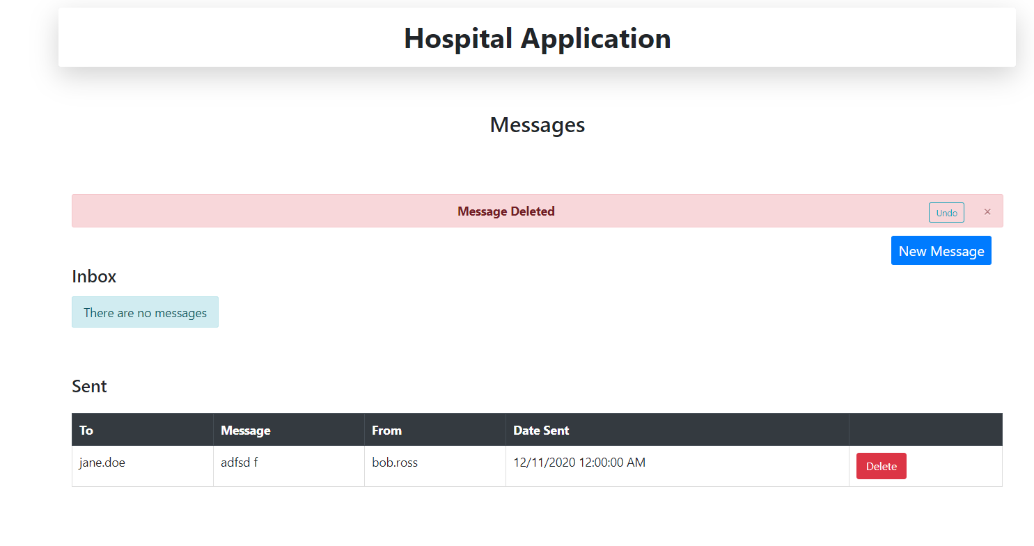

* 1. Appointment Scheduled

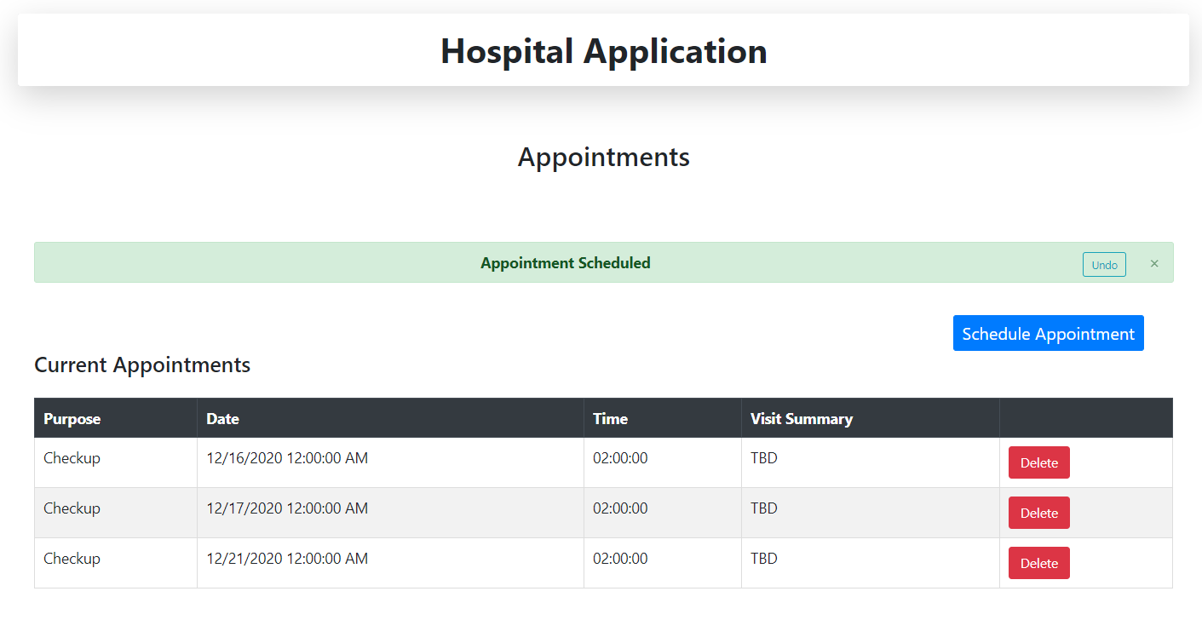

* 1. Appointment Deleted

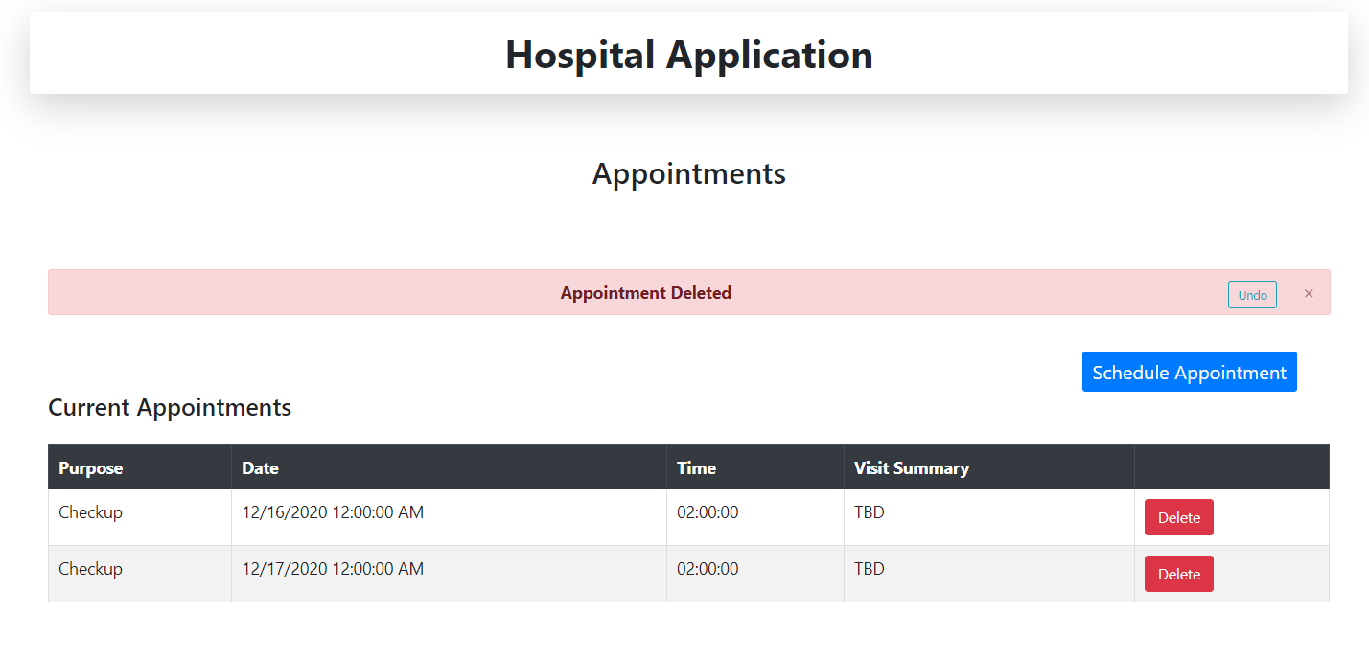

1. Undo buttons
   1. After a user sends/deletes a message/appointment, they can click “Undo” to undo the action

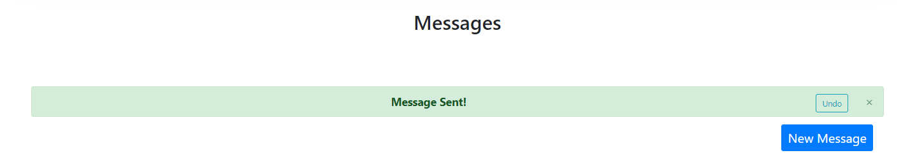

1. Tables that show only important information
   1. Tables show only useful information to the user, and don't include things like message ID and a “To” address for the inbox

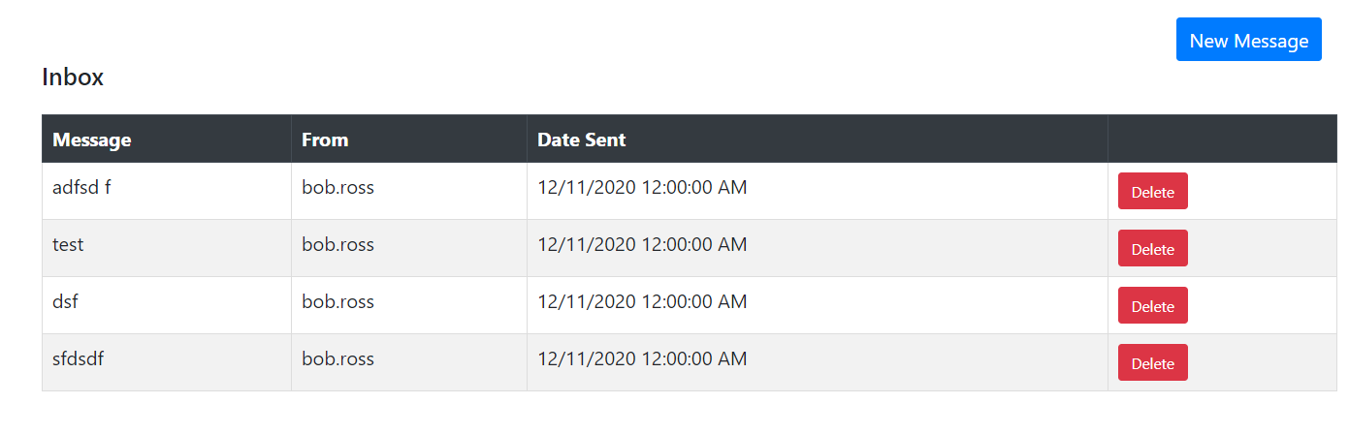

1. Form validation and error handling
   1. The site ensures the user is unable to submit a message/appointment without filling in all the information necessary

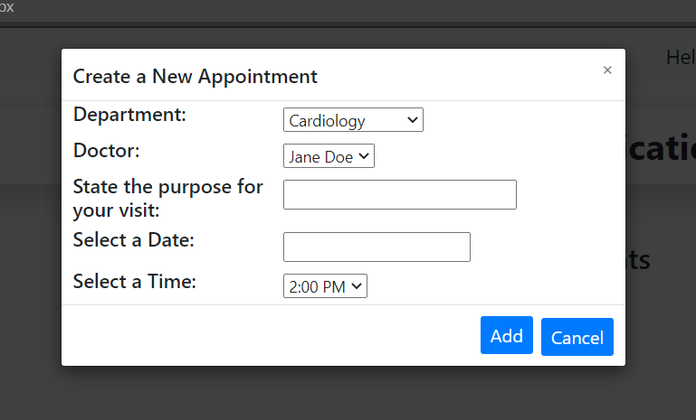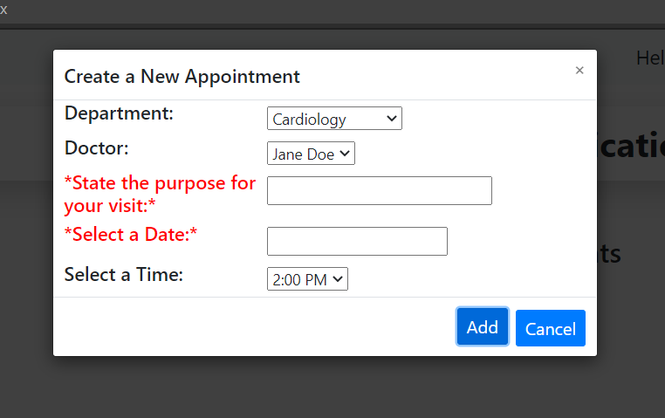

1. Confirmation Forms for sending and deleting messages and such
   1. After the user clicks to create/delete an appointment, a popup asks them to confirm the message be sent

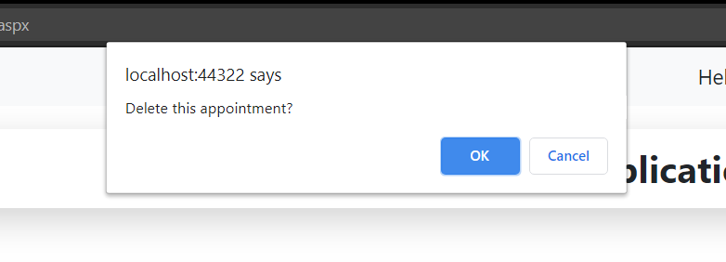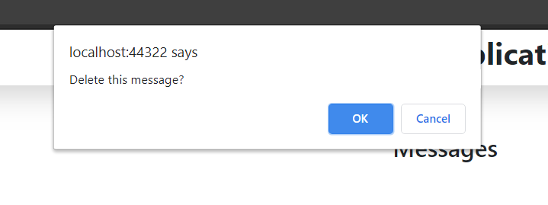

1. Left side menu bar
   1. A menu bar is included on the left side of the screen offering navigation options to the user

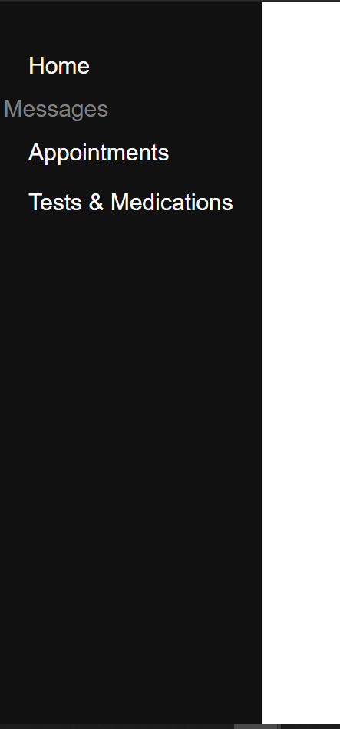

1. Login/Logout
   1. Users can login as one of two roles, patient, or doctor

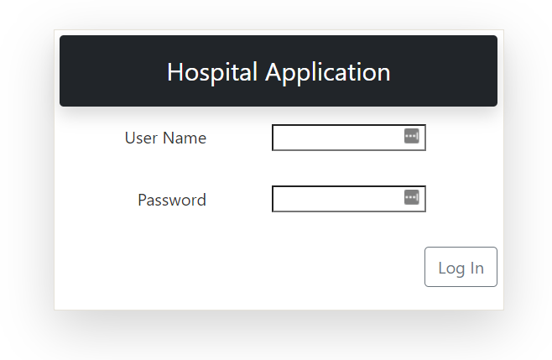

1. Send Messages
   1. Patients can send messages to their doctors or vise versa

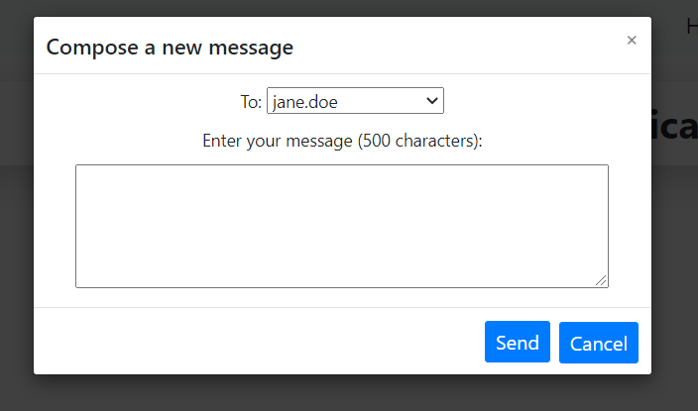

1. Appointment Creation
   1. Users can create appointments with their doctors, with selections for date and time



1. Entry Deletion
   1. The user had the option to delete messages and appointment entries



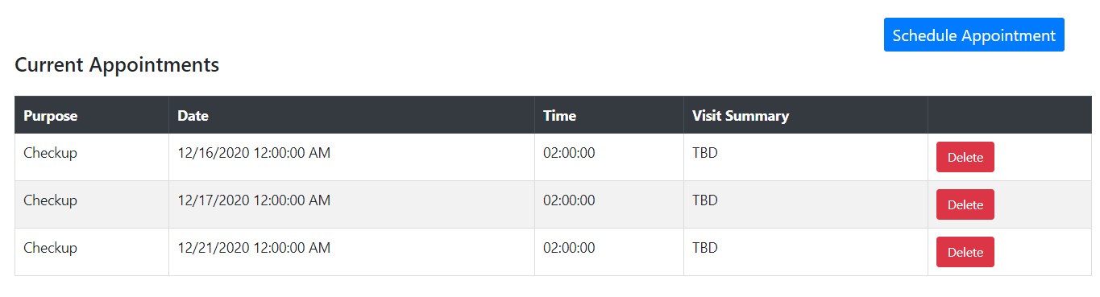

1. Patient Search
   1. Doctors can view and search through their patients

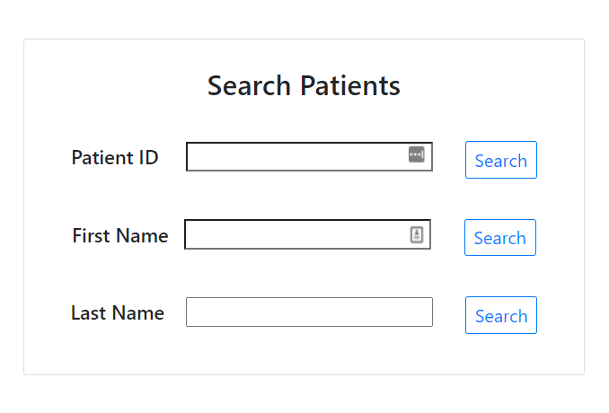

1. Patient Sorting
   1. Sort between All Patients and My Patients when logged in as a Doctor

All Patients

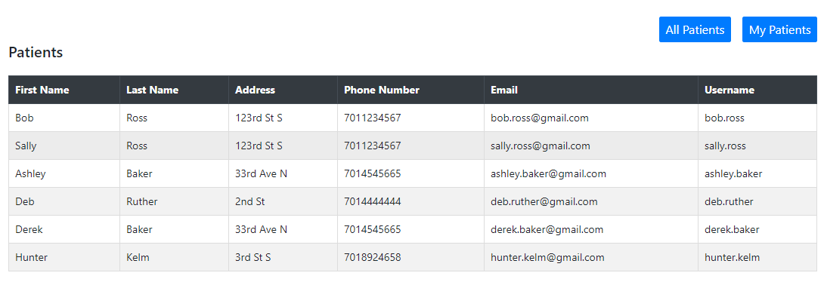

My Patients

